Design Review Report
Rev. Design_Review_Report_V1.0
Date: 2023-09-09

About the Document

History
Revision | Date | Author | Description
1.0 | 2023-09-10 | Lim.Peng/Raj | Initial Version

Contents
Contents 3
1 Scope 4
2 Design Review 4
3 Schematic Review 5
3.1. EMMC 5
3.2. USIM 6
3.3. PWRKEY & RESET 7
3.4. ADC 7
3.5. KEY PAD 8
3.6. RF 10

- Scope

The aim of this document is to describe suggestions and corrections that Quectel advises to improve application that integrates Quectel EC200U module.

- Design Review

Design review is based on the following received documentation:
- LTE_EC200U
- Schematic Review

  - EMMC
It is suggested to reserve bypass capacitors and 0R series resistors for debugging

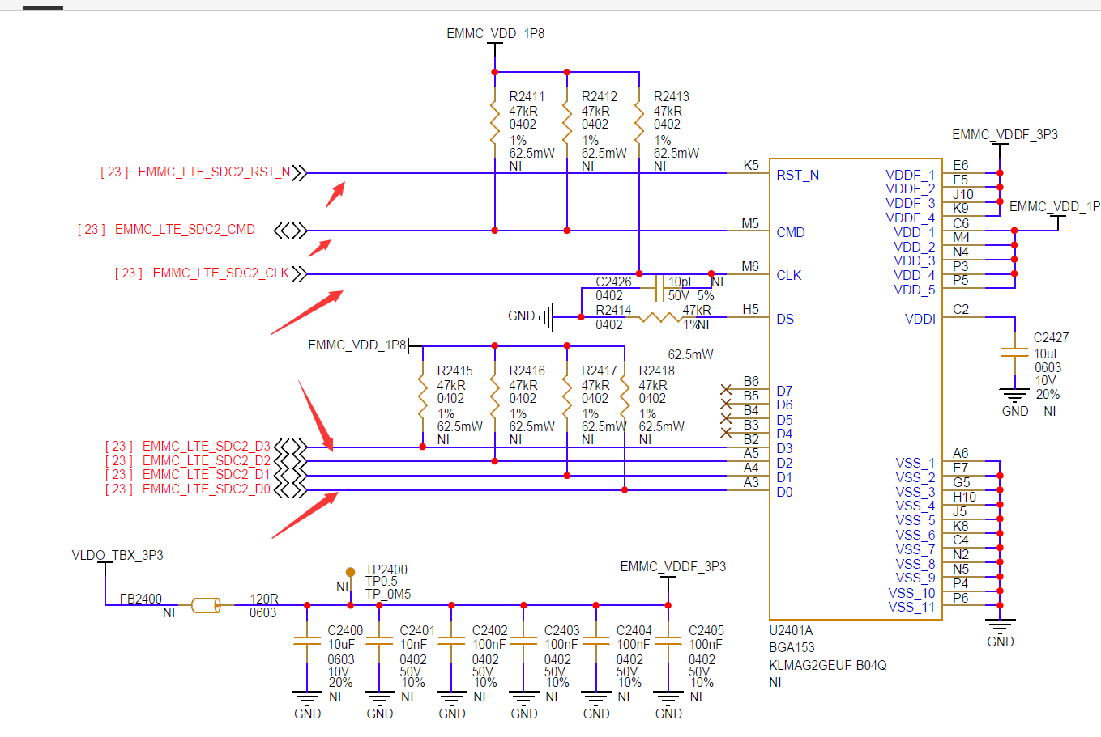
This is the reference design:
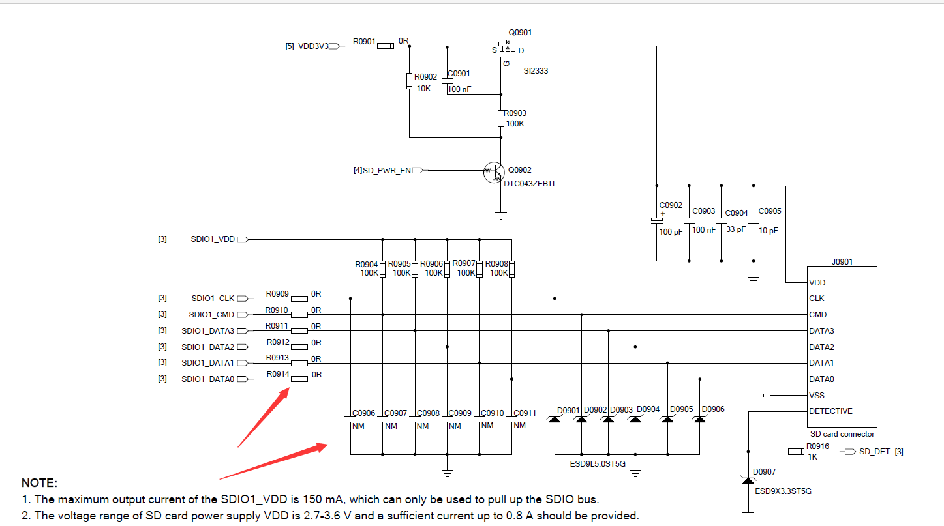

  - USIM
- Recommended USIM_DATA to be pulled up to USIM_VDD through 15K ohm.
- USIM_RST is being wrongly connected to CLK, USIM_CLK is being wrongly connected to RST.
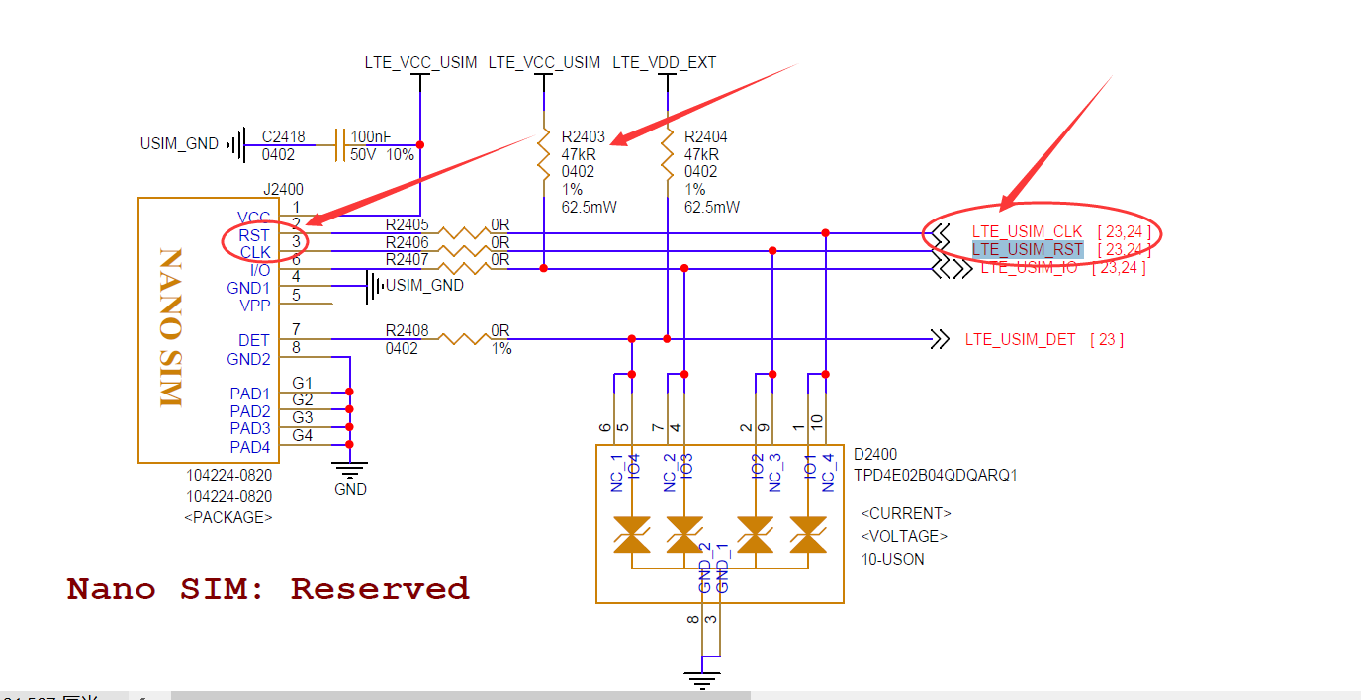

This is the reference design:
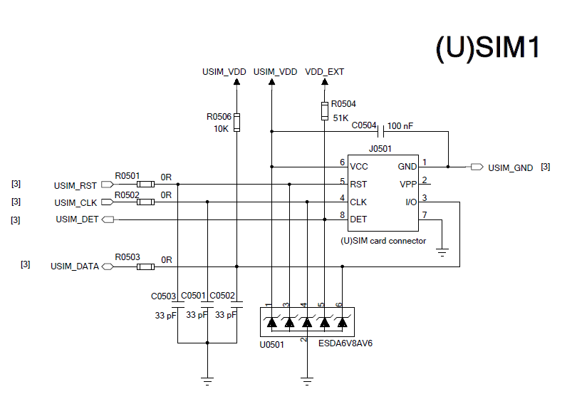
  - PWRKEY & RESET
- Remove the 100nF for RESET.
- Change 100nF to 10nF for PWREKY

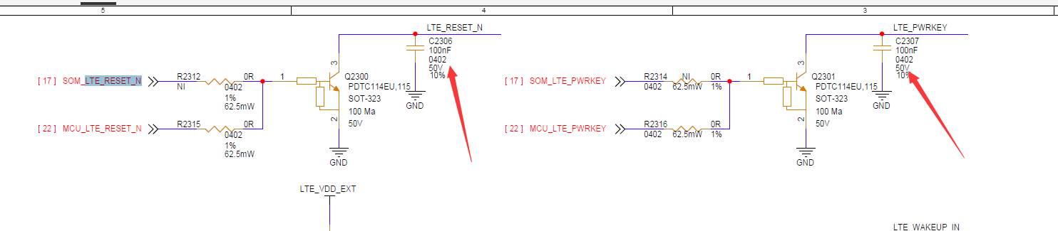

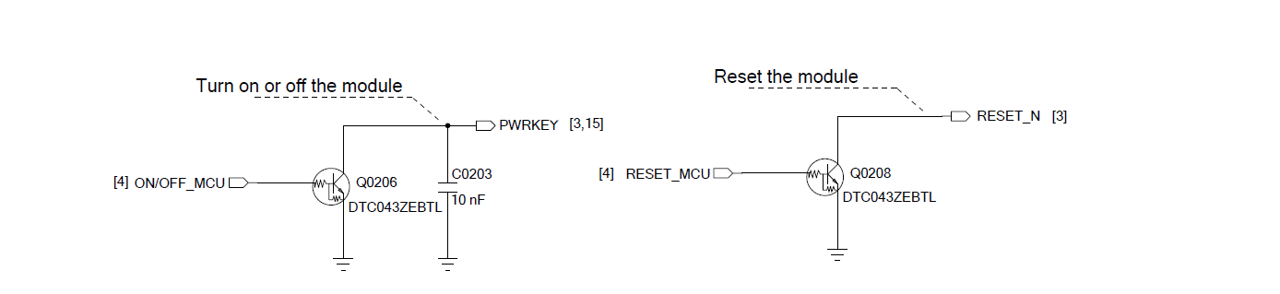
  - ADC
For better accurcy of ADC, the telorance of the resistors are recommended to be 1%.
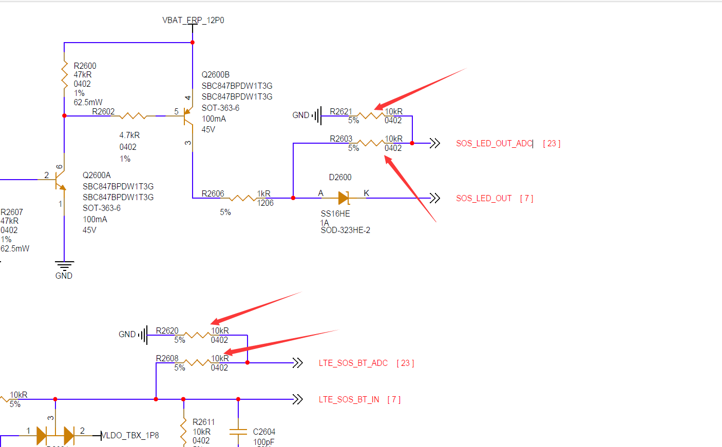
If divider circuit is not needed, 10K series resistor is reommended.
Please check the following design of ADC0. No need to pull it down.
And R2321 is recommended to be 10K as well.
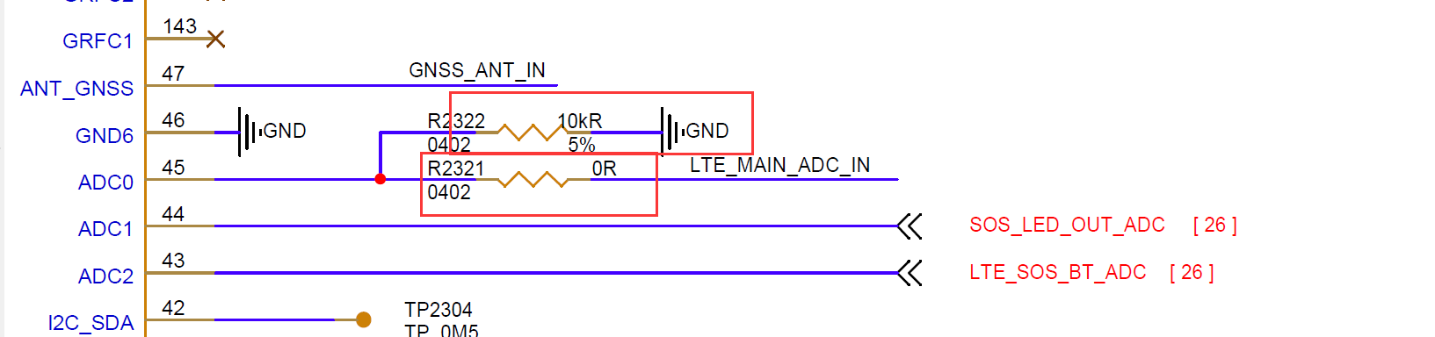
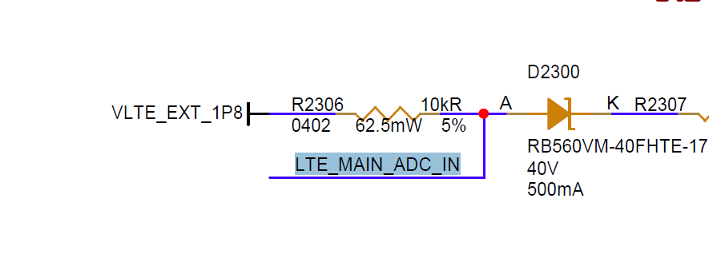
  - KEY PAD
Those pins are used for key pad specially, cannot be configurated as GPIO. Besides, those power domains cannot match.
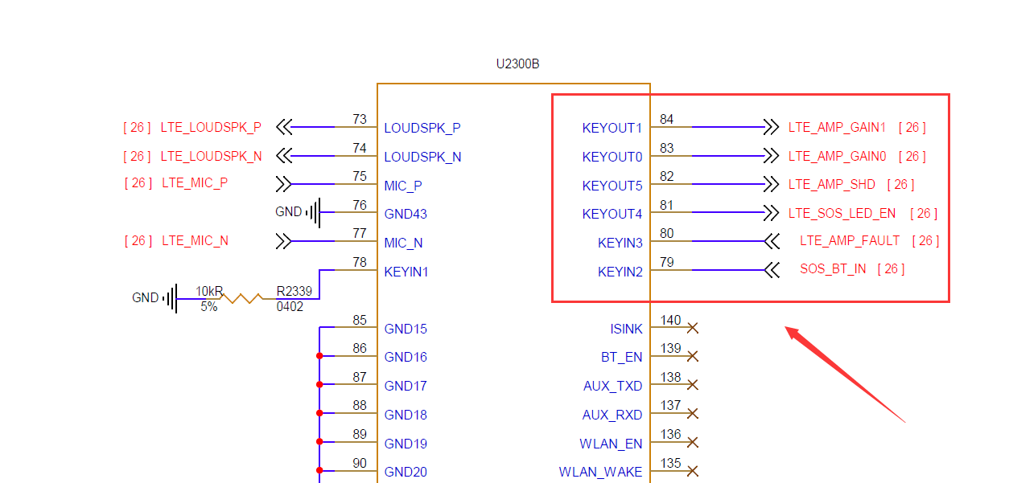
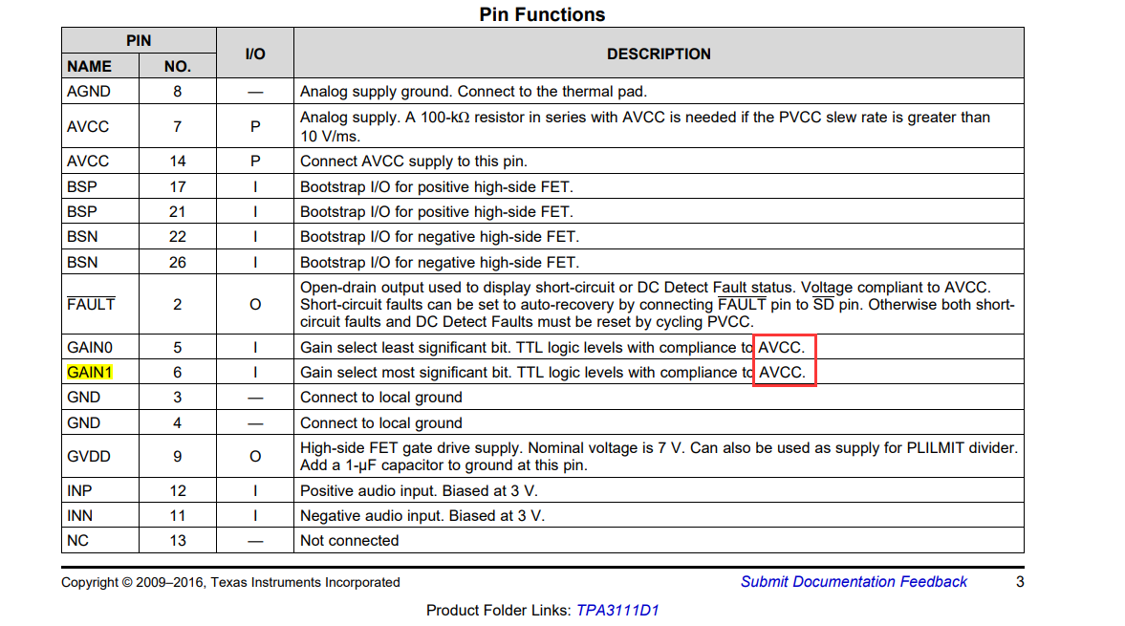

  - RF
- If external TVS is needed, the parasitic capacitance should be less than 0.05pF to ensure RF performance.
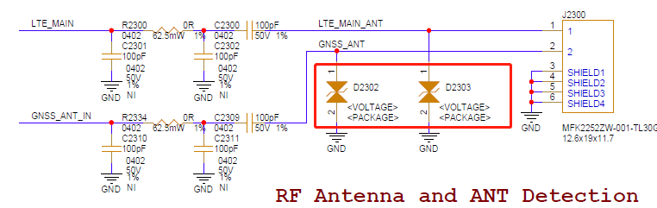

- Please confirm whether the GNSS is active antenna or passive antenna.
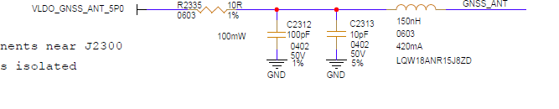
If active GNNS antenna reference design is shown as below:
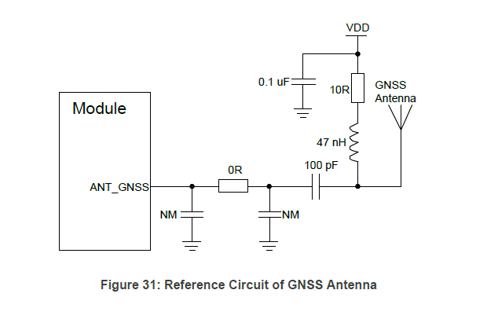

3. Recommended to follow the reference detection circuit

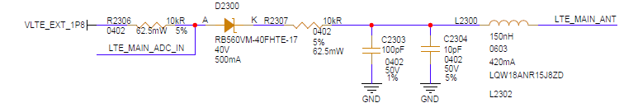

Reference Detection Circuit
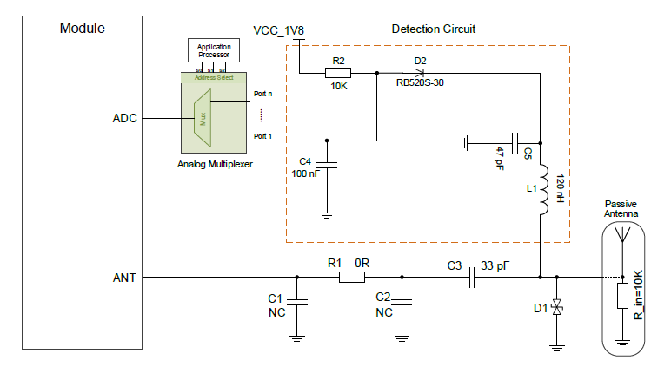
If the amount of available ADC is more than the antennas need to be detected, then the “Analog Multiplexer” may not be required. Otherwise, an Analog Multiplexer should be considered.

4. Please verify the Fakra pin isolation with the manufacturer. Isolating helps prevent interference and signal crosstalk between adjacent, ensuring the integrity of the connections and the quality of the transmitted signals.

Layout Guidelines

- Digital circuits such as (U)SIM card, USB interface, camera module and display connector should be kept away from the antennas.

- The reference ground of RF traces should be complete. Adding some ground vias around RF traces and the reference ground could help improve RF performance.

- Keep 50 characteristic impedance for the RF trace.

- It is recommended to have vias fencing around the whole board edge.

- It is recommended to reserve placeholder for shielding frame to switcher circuit and other sensor ICs to prevent EMI/EMC issues.

- Antenna isolation for each antenna should be at least 15dB to 20dB, for better RF performance and receiver sensitivity.

- For optimal performance, ensure that there is a minimum separation of 10mm to 15mm between the module and the antenna.

